SIMATS ENGINEERING

ASSESSMENT TOOL 1

COURSE NAME: Artificial Intelligence COURSE CODE: CSA17

COURSE OUTCOME COVERED
CO5: Design AI-based systems using PySpark, RDD operations, and intelligent agent architectures, using scalable systems and integrate components in distributed AI applications. (BTL 5)
Assessment Tool Weightage: 50%

Duration : 1 Hour
QUESTIONS: 5 Total Marks:50
Annexure A

Design Task

Code of Conduct:

I D. Lokesh (192312550) (Name / Reg No) certify that this submission is my original work and that I have adhered to the guidelines specified for this assessment.
I understand that any violation of academic integrity rules will result in disciplinary action.
Signature of the student: T.Charani Kirthi Sri

Annexure A

Design Task
- Hybrid AI Recommendation Engine Design Design a hybrid AI-based recommendation system that integrates content-based and collaborative filtering techniques using PySpark RDDs. Explain how distributed data processing can be used to handle large-scale user-item interactions, and describe the role of intelligent agents in adapting recommendations based on user behavior and feedback in real time.

- Smart Disaster Detection System Develop a distributed AI system using PySpark and RDD operations to detect natural disasters (such as floods or earthquakes) from multi-source data streams (satellite images, sensors, and social media). Describe the system architecture, data fusion techniques, and how intelligent agents coordinate to provide early warnings and response strategies.

- AI-Based Fraud Detection Framework Design a scalable fraud detection system using PySpark RDDs to process large volumes of financial transactions. Explain how anomaly detection algorithms can be implemented in a distributed manner and how intelligent agents collaborate to identify suspicious patterns, trigger alerts, and continuously improve detection accuracy.

- Autonomous Supply Chain Optimization System Construct a distributed AI system using PySpark for optimizing supply chain operations (inventory, logistics, demand forecasting). Describe how RDD transformations support large-scale data processing and how multiple intelligent agents interact to make decentralized decisions for cost minimization and efficiency improvement.

- Personalized Learning Analytics Platform Design an AI-driven educational platform that uses PySpark and RDDs to analyze student learning behavior and performance data. Explain how the system supports adaptive learning through intelligent agents, real-time feedback, and scalable analytics to personalize content delivery for thousands of learners.

Hybrid AI Recommendation Engine Design
A Hybrid AI Recommendation Engine combines Content-Based Filtering and Collaborative Filtering to provide better and more personalized recommendations.

System Architecture
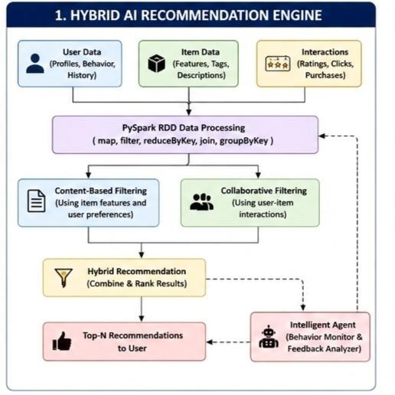

Role of PySpark RDDs
Large-scale user-item interactions are stored as RDDs. Operations such as:
  - map() – extracts user preferences and item features.
  - filter() – removes invalid or irrelevant data.
  - reduceByKey() – aggregates ratings and interactions.
  - join() – combines user and item information.
  - groupByKey() – groups interactions by user or item.
Because RDDs are distributed across multiple computers, millions of ratings can be processed in parallel.

Intelligent Agents
Intelligent agents continuously monitor:
  - User clicks

  - Purchases
  - Ratings
  - Search history
  - Feedback
The agents update user preferences in real time and adjust the importance of content-based and collaborative recommendations. For example, if a user starts searching for programming courses, the agent increases recommendations related to programming.
Result: The system provides scalable, adaptive, and personalized recommendations.

Smart Disaster Detection System
A Smart Disaster Detection System uses distributed AI to identify disasters such as floods, earthquakes, cyclones, and fires from multiple data sources.

System Architecture
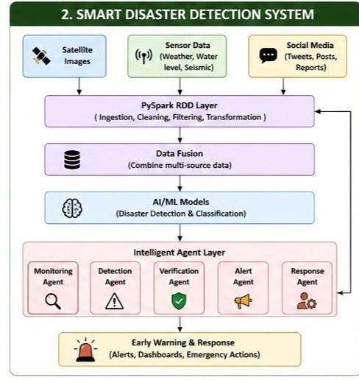

Data Processing Using RDDs
Different data sources are converted into RDDs and processed in parallel. Sensor RDD
Satellite RDD

Social Media RDD
↓
Cleaning and Filtering
↓
Feature Extraction
↓
Data Fusion
↓
Disaster Prediction
RDD operations such as map(), filter(), union(), and reduceByKey() combine and analyze large volumes of data efficiently.
Data Fusion Techniques The system combines:
- Satellite images – identify water levels, smoke, and land changes.
- Sensors – measure rainfall, temperature, vibration, and water level.
- Social media – detect disaster-related messages and locations. AI models analyze all sources together to improve detection accuracy. Intelligent Agent Coordination
Different agents perform specialized tasks:
- Monitoring Agent – collects real-time data.
- Detection Agent – identifies possible disasters.
- Verification Agent – confirms the event using multiple sources.
- Alert Agent – sends warnings to authorities and citizens.
- Response Agent – suggests evacuation routes and emergency actions.
Result: Early warnings can be generated quickly, helping reduce damage and save lives.

AI-Based Fraud Detection Framework
This system analyzes large volumes of financial transactions to detect suspicious or fraudulent activities.

System Architecture

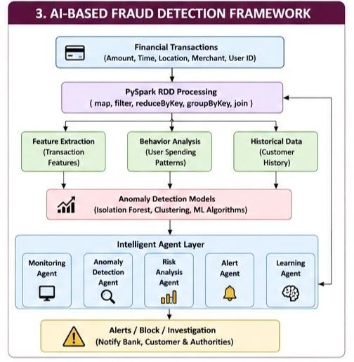

Distributed Processing
Transactions can be represented as: (transaction_id, user_id, amount, location, time)
PySpark distributes these records across multiple nodes. RDD operations are used as follows:
  - map() – extracts transaction features.
  - filter() – removes invalid transactions.
  - reduceByKey() – calculates total transaction activity.
  - groupByKey() – groups transactions by customer.
  - join() – combines transaction data with customer history.

Anomaly Detection
The distributed system identifies unusual behavior such as:
  - Very large transactions
  - Multiple transactions in a short time
  - Transactions from unusual locations

  - Unusual spending patterns
  - Sudden changes in account behavior
Algorithms such as Isolation Forest, clustering, statistical analysis, and machine learning classifiers can detect anomalies.

Intelligent Agents
  - Transaction Monitoring Agent monitors incoming transactions.
  - Anomaly Detection Agent identifies suspicious behavior.
  - Risk Analysis Agent calculates fraud probability.
  - Alert Agent notifies the bank or customer.
  - Learning Agent uses feedback from confirmed fraud cases to improve the model. Result: The framework provides scalable and continuously improving fraud detection.

Autonomous Supply Chain Optimization System
This system uses distributed AI and PySpark to optimize inventory, transportation, logistics, and demand forecasting.

System Architecture
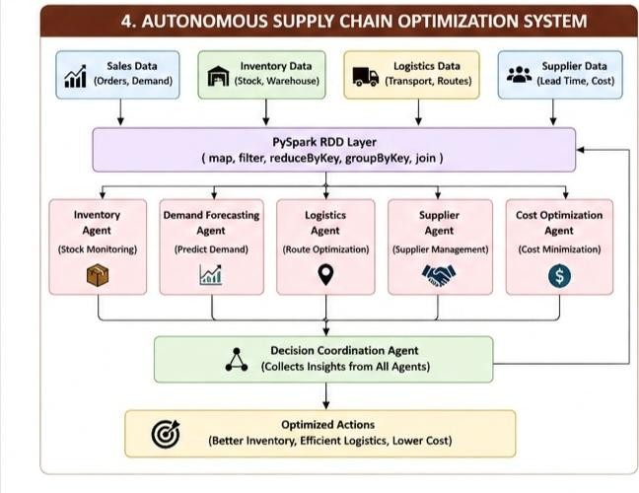

RDD Transformations
PySpark RDDs process large supply chain datasets using:

  - map() – converts raw data into useful records.
  - filter() – removes unnecessary records.
  - reduceByKey() – calculates total demand or inventory.
  - groupByKey() – groups products by location.
  - join() – combines supplier, inventory, and transportation data.

Intelligent Agents
- Inventory Agent – monitors stock levels and prevents shortages.
- Demand Forecasting Agent – predicts future product demand.
- Logistics Agent – selects efficient transportation routes.
- Supplier Agent – communicates with suppliers.
- Cost Optimization Agent – minimizes operational costs.
The agents communicate and make decentralized decisions. For example, when demand increases, the demand agent informs the inventory agent, which requests additional stock, while the logistics agent selects the best delivery route.
Result: Lower costs, faster delivery, better inventory management, and improved efficiency.

Personalized Learning Analytics Platform
A Personalized Learning Analytics Platform uses AI and PySpark to analyze the learning behavior and performance of thousands of students.

System Architecture
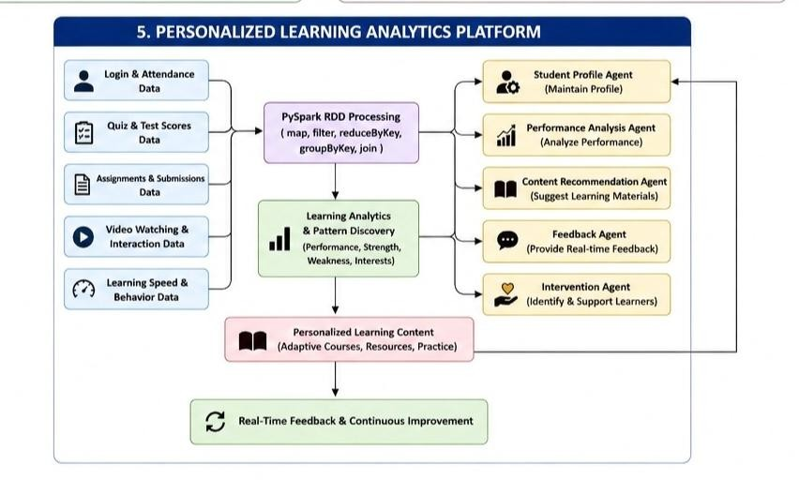

PySpark RDD Processing
Student data is distributed across multiple computing nodes. RDD transformations process data efficiently:
  - map() – extracts student performance features.
  - filter() – identifies students requiring support.
  - reduceByKey() – calculates total scores.
  - groupByKey() – groups activities by student.
  - join() – combines performance and behavioral data.
This makes the platform scalable for thousands or millions of learners.

Intelligent Agents
  - Student Profile Agent – maintains learner preferences and performance.
  - Performance Analysis Agent – identifies strengths and weaknesses.
  - Content Recommendation Agent – suggests suitable learning materials.
  - Feedback Agent – provides immediate feedback.
  - Intervention Agent – identifies struggling students and recommends support.

Adaptive Learning
For example:
Low Quiz Score
↓
Analysis Agent
↓
Identify Weak Topic
↓
Recommendation Agent
↓
Provide Basic Videos and Exercises
↓
Student Performance Improves
↓
Update Learning Profile
Result: Each student receives personalized content, adaptive learning paths, and real-time feedback while PySpark ensures the platform can handle large-scale educational data.

